SEAHORSES OF THE RIVER THAMES
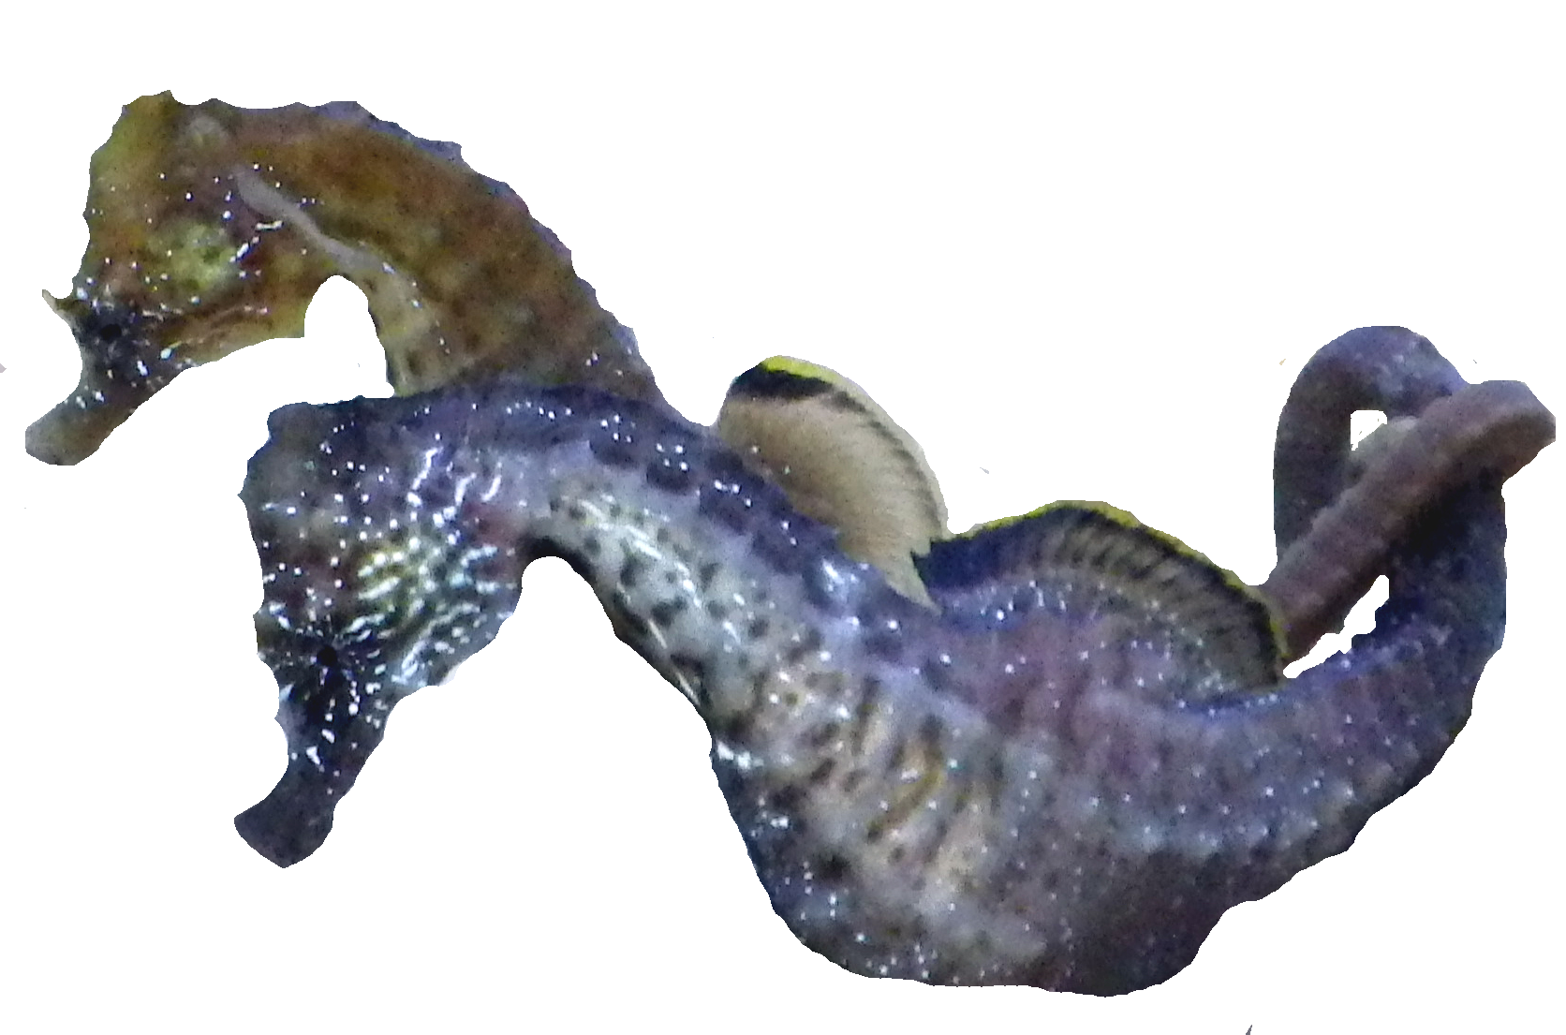
By Neil Garrick-Maidment Hon.FBNA
Founder and Executive Director of The Seahorse Trust

Seahorses of the River Thames
British seahorses
The British Isles has two species of seahorse, the Short Snouted Hippocampus hippocampus and the Spiny Seahorse Hippocampus guttulatus (sometimes wrongly called the Long Snouted Seahorse).
The Seahorse Trust achieved recognition for seahorses as a native species and full legal protection for both species on the 6th of April 2008 and they are protected under the Wildlife and Countryside Act 1981 (as amended) as a schedule 5, section 9 species.
Data from the National (now World) Seahorse Database allowed us to present the species as native, and as a permanent resident, as opposed to being a transient, temporary visitor as previously thought. We have records dating back to 1721 proving the species is indeed a native species and surveys conducted by the trust under the British Seahorse Survey (https://www.theseahorsetrust.org/conservation/british-seahorse-survey-2/ ) at 6 sites in England have shown presence, breeding, pairing and territoriality. All this has shown the two species are indigenous and have been present for a very long time,
The Romans and Picts recorded seahorses through their art work back in the 1st and 3rd centuries respectively.

Their distribution is fully around the UK, Ireland and out into the North Sea. They are also found in all of the nation’s surrounding the North Sea and down into and on both sides of the English Channel; these countries include Scotland. England, Norway, Sweden, Denmark, Germany, the Netherlands, Belgium, France, and Portugal, amongst others.
Short Snouted Seahorse Spiny Seahorse
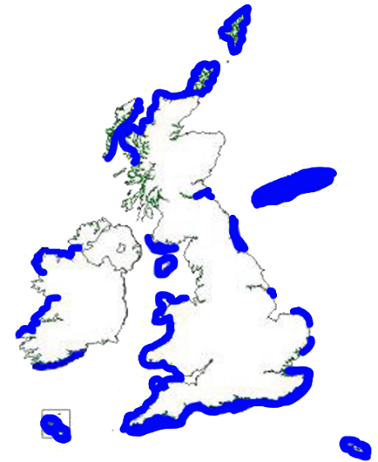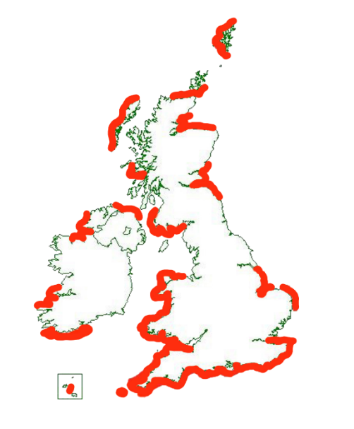
Please note an absence of records in the maps above does not mean an absence of seahorses in an area. It is just they have not been proven to exist or not exist there at the present time.
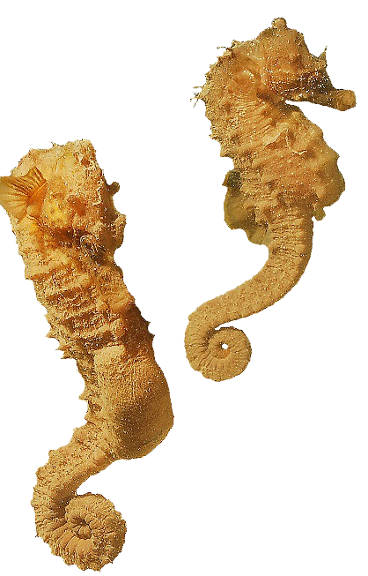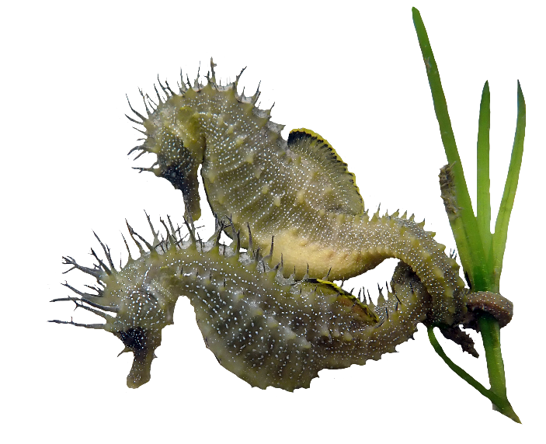
Short Snouted Seahorse Spiny Seahorse
Picture by John Newman Picture by Neil Garrick-Maidment

Suitable habitat
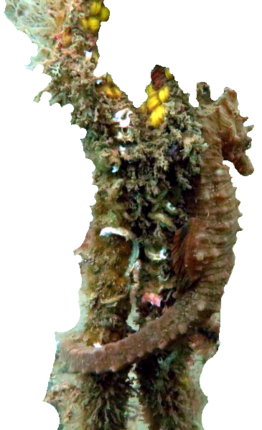
The two seahorses fall into distinct categories when it comes to habitat.

The Spiny Seahorse really should be renamed the Seagrass Seahorse as this is its preferred habitat, and it is highly adapted to seagrass and similar algae.

The Short Snouted Seahorse is a generalist and can be found anywhere from human-caused objects to marinas, rocks, and sandy areas to rarely seagrass meadows.

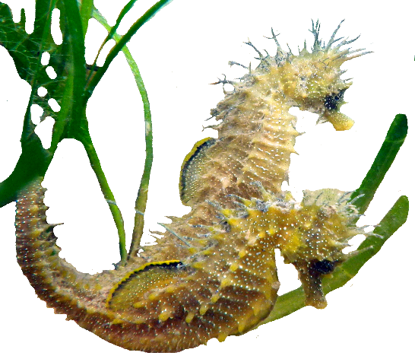
What is interesting about the Thames sightings referred to in this article is that the habitats are extreme, due to the flow of water and at various times of year this can become very extreme. The habitat is the most extreme you would expect the species to live in, here in the UK. There is also little visibility, which for a species that is reliant on its eyesight to hunt for food and to find a mate makes it a harsh environment to live in. The seahorses amazing olfactory senses means it can find both, food and mates.
Short Snouted Seahorse
Picture by Kim Maidment

Freshwater Seahorses
Both species are found in coastal areas, with depths ranging from 1 metre to over 70 metres depending on the time of year (average in the winter 20 to 30 metres), as they have a seasonal migration, depending on where they live in the shallows.

Seahorses in enclosed areas such as Torbay and Poole Harbour are thought not to migrate, as the reason for them migrating, includes strong storms and waves crashing into the shallows (which could kill them, either directly or by strandings) and these do not happen as violently in protected, sheltered sites.
It also takes a great deal of energy, loss of condition and risk of predation to migrate into and out of the depths; so, if migration can be avoided, they will do.

During the winter months for those that do migrate, they are both found in the same weedless habitats at depth (average in the winter 20 to 30 metres) to avoid the devastating storms that can wash them onto the beach and kill them.

The exception to this is on Dogger Bank in the North Sea that is a shallow area (up to 20 metres) just to the east of the British Isles which, within the last few thousand years was farmland and formed a large plateau and an eastern extension to England, covering some 25,000 square kilometres, that was subsequently submerged as sea levels rose.

Surprisingly, they are also found up and into estuaries and tidal river systems, as far up in the river ecosystems as the brackish areas, where the freshwater meets saltwater. There have even been a few reports of seahorses in freshwater, however, this is never more than just into it, and it is not thought they live in freshwater for any period of time here in the UK.

One such report by the Marine Biological Association in 2004, found a seahorse up the River Tamar in freshwater above a site called Cargreen, which is fully freshwater, but it is assumed this was just a temporary area for the seahorse and they were not resident there.

Interestingly, there is thought to be a freshwater seahorse species in the Mekong River, although no live specimens have ever been found. However, there are freshwater pipefish in river systems in Asia, and these are the closest relatives to seahorses, so it could be that seahorses have actually evolved in some areas to live in freshwater. Until evidence is shown either way, we need to keep an open mind on this.

It is common to have sightings of seahorses in estuaries and open sea but not so common to have the records and sightings fully up river systems.

Thames Seahorses
So, what is happening with seahorses in the River Thames where they are found some 11 to 13 miles inland from the Thames estuary? We have records from Battersea all the way down to the estuary mouth between Essex and Kent.

The Thames is an unusual river for the UK, in that the seawater penetrates a long way inland some 55 to 68 miles. The river itself is 235 miles long from its source in the Cotswolds at Thames Head and the tidal Thames is approximately 95 miles long. As such, a variety of marine based creatures are found in this busy waterway. Over the years there have even been whale species right into the centre of the city of London.
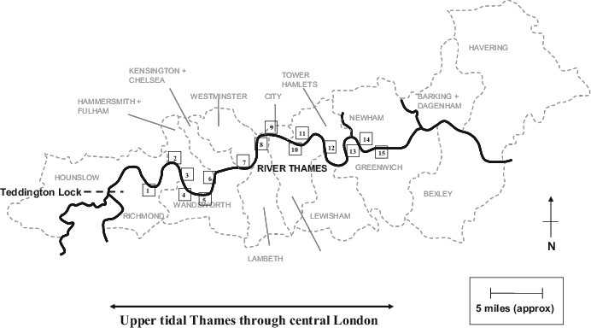

Seahorses are not commonly thought to be in busy rivers, due to noise, disturbance, pollution and sheer flow of water. However, it seems that conditions in the Thames appear ideal for the Short Snouted Seahorse and by the estuary mouth for the Spiny and Short Snouted Seahorses.
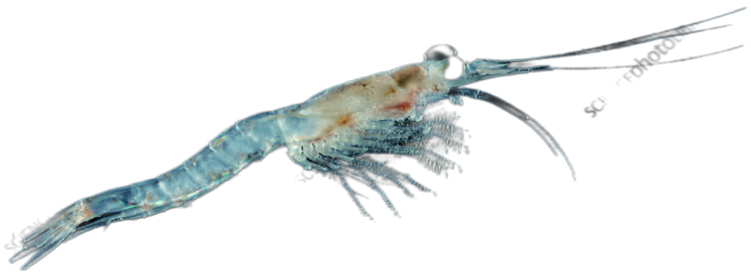
There appears to be a lot of food for fish such as seahorses with an abundance of shrimp and small crustacea for them to live on. This is probably because of all the human habitation which creates a nutrient rich water system that is beneficial for crustacea and food species and in turn other species.
Mysis Shrimp
This abundance of food would encourage a voracious predator such as the seahorse into the river system and if there were also copious amounts of plankton then this would provide a steady supply of food for seahorse fry as they breed.
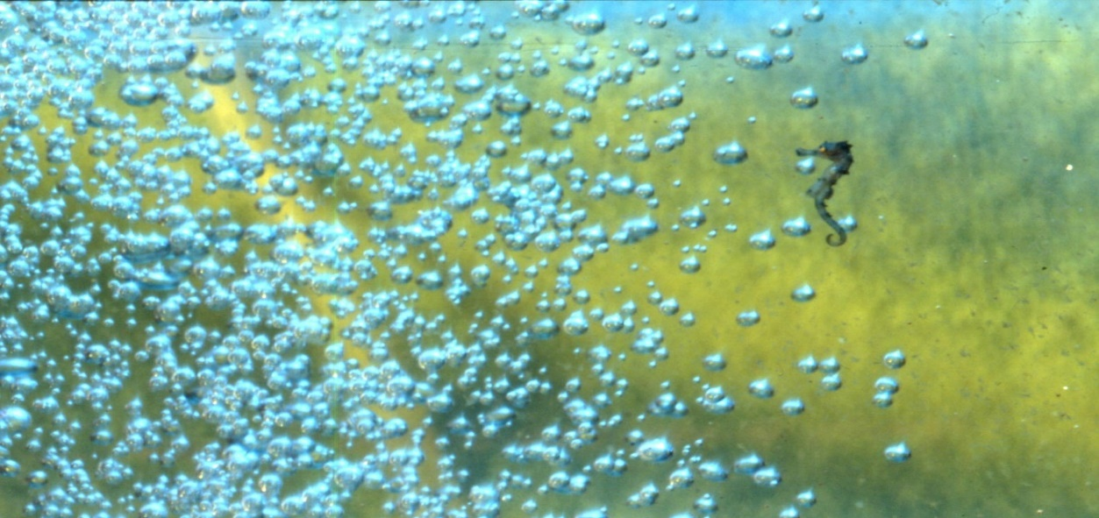
Seahorse fry of a Spiny Seahorse
Picture by Francis Apesteguy

Seahorses have huge appetites, due to a basic digestive system that does not include a stomach, where food can sit and be digested. Instead, they just have a digestive tract, which means they have to constantly be eating to get enough nutrition from their food which is partially digested. An adult seahorse will eat up to a hundred or more 2cm long shrimp per day – such as Mysis Shrimp - and the seahorse fry in excess of 3,000 pieces of plankton in a 24-hour period. Any site that satisfies this requirement would be perfect for seahorses as long as there are suitable holdfasts so they can hold on in the tidal stream and not get washed away.

Adult seahorses have a phenomenal prehensile tail that can curl around objects and weeds – even single blades of seagrass leaves - and hang on in the most extreme of conditions and the strong flows of the River Thames would be no problem for them.
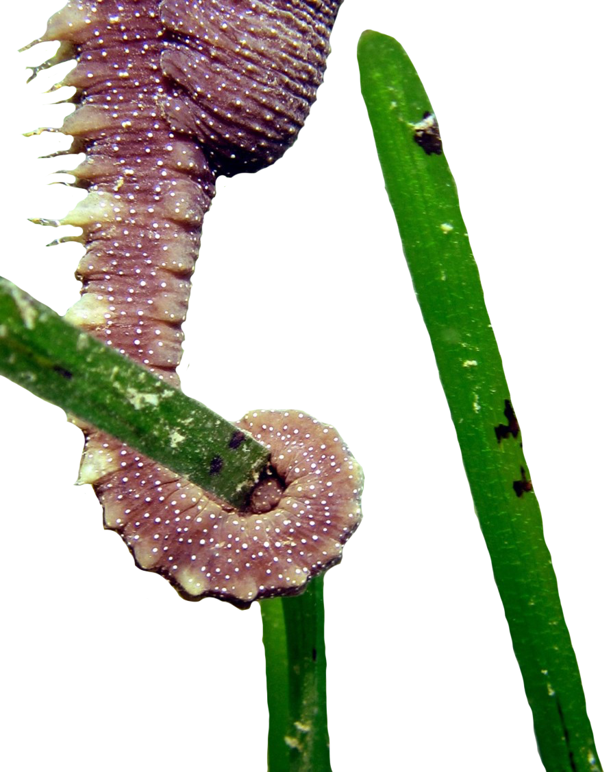

Tail of a Spiny Seahorse holding onto seagrass
Picture by The Seahorse Trust

There is a difference in growth rate of male and female seahorses, which is reflected in the ratio of a higher number of female to males stranded on the river banks in the Thames. One of the reasons for the bias in this ratio is male seahorses grow faster and have stronger tails and can grip on in harsher conditions than females. When a flood occurs, the males have a better chance of holding onto the holdfast and the females will be washed away down the river to possibly be stranded, sadly, leading to death in a lot of cases.
Seasonal changes
During the calmer, warmer periods of the year the adult seahorses find mates, possibly pairing for the breeding season, exchange eggs from the female into the male, via an ovipositor, where he self-fertilises and then he gives birth 25 to 28 days later, depending on the species. Often giving birth to up to 500 fry at a time for a fully grown male Short Snouted Seahorse, sometimes more in large individuals, depending how successful the egg exchange was between the female into the male. As exchange takes place very quickly, in the water column eggs are often spilled onto the seabed where they are not fertilised and end up as food for other fish species.
Seahorse eggs picture by Gaynor Rosier
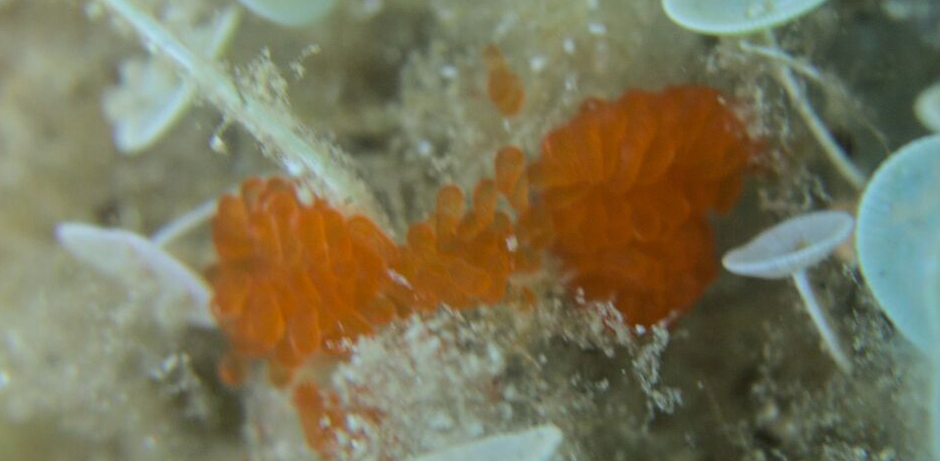
Unfortunately for seahorse fry, they are the ideal bite sized bit of food for so many fish species, resulting in only 1 or 2 in a thousand surviving to any size, possibly more if predation is not high. Lots of species are known to eat the fry including fish and crabs.
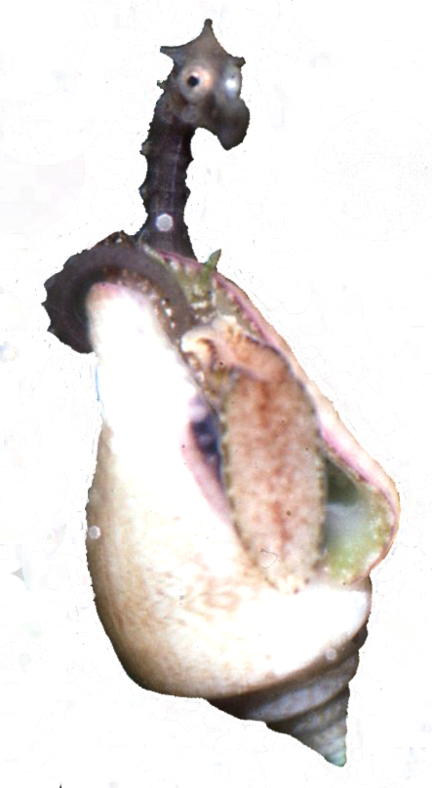
Despite the high level of predation of the fry, they are a successful species, and their unique breeding cycle means there are a constant number of fry being born every month, especially in the warmer months of the year.
Parental care is non-existent and once born, they are entirely on their own where they feed in the plankton zone until they are big enough to settle on the seabed and hold on with their prehensile tails. Holding on to stop being washed away but also hiding in algae and amongst other objects to avoid predation from other fish species. We even have records of seagulls and other bird species eating seahorses.
We do not have records for seahorses in the Thames during the winter and it is feasible they migrate down the river to the estuary, but it is a long way to work their way back up again in the spring (They might even follow the shrimp up the river as they return in the spring) and so at present we do not know what is happening the whole year around. Over time, and as more information comes in, we hope to piece together a year around pattern of seahorse movements in the Thames. We also hope to eventually work out how high up the Thames they go and if they spend much time in the brackish are of the Thames.
Seahorse fry holding onto a snail.
Picture by Neil Garrick-Maidment

Flooding of the River Thames
During the spring and especially the early summer months in hot years, the level of water drops in the Thames, it is calmer because there are not the heavy rains of Autumn and Winter. This calmness allows the seahorses to breed in large numbers and with the heat of the sun there is plenty of food around to feed the adults and the fry. The phytoplankton is eaten by the zooplankton, and the seahorse fry eat the zooplankton. Seahorses do not eat plant life directly as they are carnivores, but phytoplankton is vital to a seahorse’s diet and wellbeing.
By the time the early autumn comes and the weather changes we tend to have lots of rain which in a long, relatively narrow river like the Thames which has been straightened and hemmed in by manmade walls means it floods quickly. Traditionally it would have spread over the extensive flood plain which is now built on, so the water has nowhere to go except rushing downstream, sweeping everything in its wake. The natural processes of the river have been destroyed by mankind building everywhere.
As it rushes downriver it creates a large volume of water particularly because the catchment area (5 to 6 thousand square miles) is vast and there are 36 main tributaries feeding into the Thames, washing away everything in its path. For most fish species this is not a problem, and they can cope with the ebbs and flows of water volume as they are free swimming and go with the flow or tidal state or can hide under rocks and other objects. However, sedentary species like seahorse have to hold tight with their prehensile tails. As powerful as the seahorse tail is, it is not always enough to stop the younger, smaller fry being washed down the river with a number of them being washed onto the river banks where frequently they die.
As a result of global warming we are having more and frequent flash floods in the mid to late summer which catches the seahorse fry/juveniles unaware, and they are not strong enough to hold on with the sudden heavy spate of water flooding down the river. This sudden flow of large quantities of water results in mass strandings and it is assumed that a large number for fry are washed down the Thames. This is backed up by similar sized fry (mainly female) being caught in scientific fish traps that are monitoring the Thames at all times. You do not see large numbers of fry being washed onto river banks and beaches, during the winter or spring and early summer.
As well as being forced off their holdfasts as the freshwater up river comes down and what would be saltwater becomes freshwater for long periods, the seahorses react to this freshwater by moving into saltwater – heading down stream. The seahorses let go of their holdfasts to move down river and the lucky ones are caught by the current being pushed down the Thames to the estuary.

How far up the Thames are they?
The highest stranding record we have to date is at Battersea (11 to 13 miles inland from the estuary mouth); however, they must be breeding further upriver to flow down to these lower areas. The tidal Thames is 95 miles long and the further up the river you go, the more freshwater there is, so it is feasible seahorses can be found some distance up river from Battersea. Tidal fluctuations means that the brackish water and freshwater do vary in the area by some miles.

We do not know exactly where the full range of the breeding seahorses goes up to, but around Battersea and just upriver by possibly 10 or so miles is most likely the highest point. Without a doubt further research is needed to fully understand what is going on in the area.
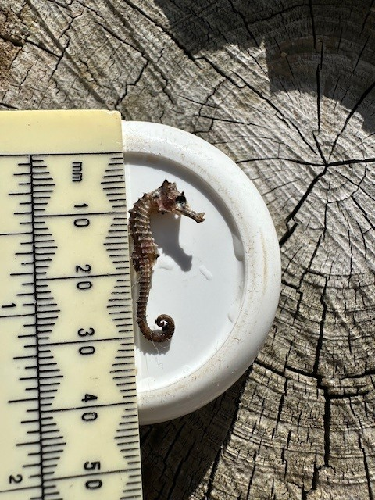
Short Snouted Seahorse found by Sandy Rutherford
We have 41 records in the river up as high as Battersea but there was most likely a lot more washed up as they are extremely hard to see with some of them being only 3 to 4 cm from the top of the coronet to the end of the tail.
As you progress further down the river into the estuary and the surrounding areas like the Medway, we do have a lot more records and these relatively sheltered areas are obviously good for seahorses, and they are most likely in them for a greater part of the year.
It is also assumed that they are also found in the tidal tributaries that feed into the Thames, especially the bigger ones that have larger bodies of water.
Numbers of seahorses in the estuary are much higher, as expected, and they are spread out fully around and out into the estuary, with both species being represented.

Discussion
Seahorses are generally not expected to be found in freshwater however the observations and findings that we have, not just on the River Thames but in other river systems here in the UK show that seahorses do things we don't expect them to do. We know they go into freshwater for short periods of time, and we know that they are capable of going into freshwater because of the construction of their gills – it resembles a bunch of grapes - allows them to go into freshwater. However, research tends to be on the coast and not inland when it comes to seahorses, so we need to do more to understand them.

Over the centuries one of the problems that we have with the River Thames is the river system is actually changed quite dramatically it no longer floods into the floodplains over the banks of the Thames and is constrained by man-made barriers and walls. By constraining the water, this actually accelerates the water rushing down through the Thames which washes everything away in its path. If species like seahorses are to be preserved these things need to be taken into account when designing the river banks and development along the river and mitigation needs to put into place to try and avoid the mass of water that just floods down through the estuary.

Seahorses are one those species that even if you had several lifetimes, you still would not be able to understand them because they are very cryptic in their way of living and ecology.
There are lots of myths and legends around them, so people assume they do not actually exist in our waters, this is the first barrier to understanding them.

A lot more research needs to be undertaken, and this is one of the things that The Seahorse Trust needs to concentrate on into the future, working in collaboration with other scientists that do surveys of various fish species along the river networks.
Only then can we get a better understanding of the distribution of seahorses around the British Isles

Thanks to:
One group of people we'd like to give a massive thanks to are the mudlarkers who spend all their time looking for artefacts, for historic items and for fish and plant species along the River Thames. These amazing volunteers are out there in all sorts of weather and are constantly walking up and down the river banks and the beaches on the River Thames. They are the ones with their sharp eyes finding the seahorses, which allows us to understand more about seahorses and their ecology. I would like to give a massive shout out to all the mudlarkers and the volunteers that report in their records to us. Thank you.

I would also like to give thanks to the various scientists that work along the River Thames and into the estuary that have kindly given us the information, records, and data about the seahorses, some of them are commercially sensitive so they cannot be shared but having that data has allowed us to understand the seahorses of the Thames better. However, a lot more needs to be done to fully understand their ecology in this complex river system. Thank you to all involved.
The Seahorse Trust
36 Greatwood Terrace
Topsham
Devon
EX3 0EB

theseahorsetrust@gmail.com
07876513628
www.theseahorsetrust.org

Registered charity 1086027

WORKING IN PARTNERSHIP WITH NATURE



